SENDING YOUR CHURCH WMO EMAILS SAMPLE EMAIL 4

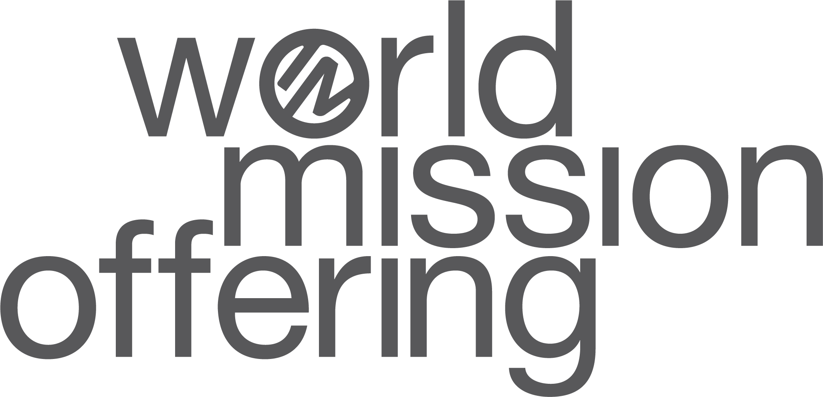

Hello!
As we’ve spent this month learning more about God’s work around the world, I hope you have been prayerfully considering the part God may be asking you to play in his global church.
We have the tremendous opportunity to commit to pray and to give as partners with International Ministries’ global servants. We can come alongside the Aragόns and Myers as they live with and serve the indigenous people groups in the mountains of Chiapas and Puebla. We can support the ministry of Ingrid Roldán-Román to satisfy both the hunger and the need for education among school-age children in Panama.
Our response to this year’s World Mission Offering is even more important this year, as IM’s global servants and partners work to respond and rebuild their ministries during and after the global pandemic.
How can you give to the World Mission Offering?
- Send your WMO gift to our church office. We send these donations through your American Baptist Churches USA regional office. If you give by check, please write ‘WMO 2020’ on the memo line.
- Send a check made payable to “International Ministries” and mail to: International Ministries – 1003 W 9th Avenue, Ste A , King of Prussia, PA 19406
- Give online at www.worldmissionoffering.org

Let’s pray together that God will build a heart for global mission in our church. I hope that the time we’ve spent this month thinking about global mission can impact us as Christians throughout the year. Kingdom work happens all year long! Any time we dedicate prayer and financial support for global mission, it will have a meaningful impact on making disciples of Jesus Christ.
With blessings,
[church pastor or mission chair]

