SENDING YOUR CHURCH WMO EMAILS SAMPLE EMAIL 1

Hello!
As you may know, in September and October our church dedicates time toward awareness, advocacy, and action for global mission as part of the World Mission Offering. We are able to participate in God’s work around the world in partnership with International Ministries (IM), a cross-cultural mission agency with a long heritage in the American Baptist mission movement.
This week, we’d like to encourage you to get to know more about the work of IM by watching this video for a window into the work of IM’s global servants and listening to their executive director, Rev. Sharon Koh, talk more about the work IM is doing around the world.
https://www.internationalministries.org/world-mission-offering/
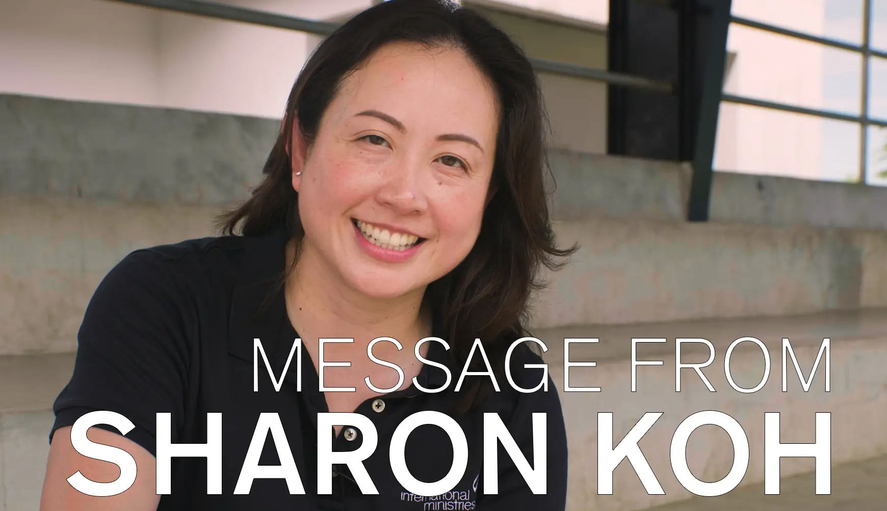
As you watch, I want to encourage you to consider prayerfully how God might be calling you, your family, and our church to participate in his global mission movement.
[You could also attach Sharon Koh’s / CEO letter with your email; download from] https://www.internationalministries.org/world-mission-offering/
With blessings,
[church pastor or mission chair]

