SENDING YOUR CHURCH WMO EMAILS SAMPLE EMAIL 1
Hello!
As you may know, in September and October our church dedicates time toward awareness, advocacy, and action for global mission as part of the World Mission Offering. We are able to participate in God’s work around the world in partnership with International Ministries (IM), a cross-cultural mission agency with a long heritage in the American Baptist mission movement and beyond.
This week, I’d like to encourage you to get to know more about the work of IM by taking a few minutes to listen to IM Executive Director Rev. Sharon Koh and IM Board President Jorge Medero-Roldán. You can watch those brief videos here.
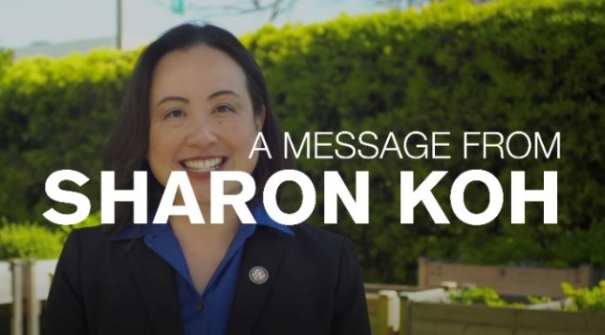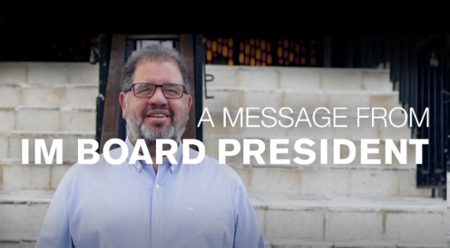
As you watch, I want to encourage you to consider prayerfully how God might be calling you, your family, and our church to participate in this global mission movement.
(Note to pastors: if you like, you can attach Sharon Koh’s letter with your email. You can download it here.

With blessings,
[church pastor or mission chair]

