SENDING YOUR CHURCH WMO EMAILS SAMPLE EMAIL 3

Hello!
As we continue our month dedicated to the World Mission Offering, I’d like to encourage you to watch three brief videos that will tell you the stories of three International Ministries (IM) service priorities. Global Servants Ketly and Vital Pierre work with Haitian immigrants facing inequity and maltreatment in the Dominican Republic. Ricardo Mayol-Bracero is partnering with churches across Latin America to help protect their access to clean water and air. Alise and Mark Juanes are providing support and care for hill tribe children in Thailand.
You can watch all three of these videos through IM’s website here.
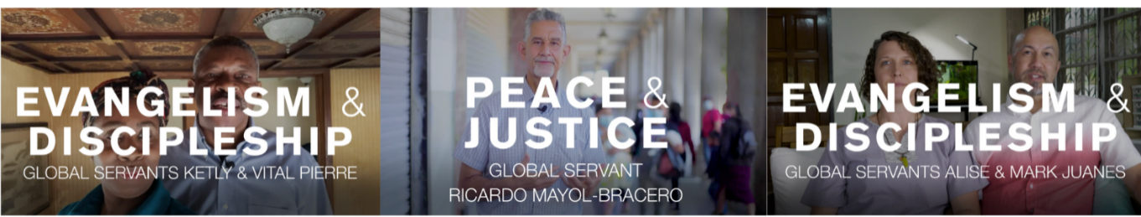
How might God call on our church to contribute to the World Mission Offering? We can become partners in something God is doing that is bigger than our church. God can use us to bring Christ’s kingdom to restore and impact places here on earth.

With blessings,
[church pastor or mission chair]

