SENDING YOUR CHURCH WMO EMAILS SAMPLE EMAIL 1

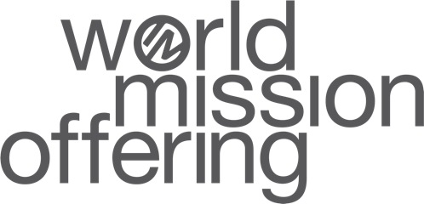

Hello!
As you may know, in September and October our church dedicates time toward awareness, advocacy, and action for global mission as part of the World Mission Offering. We are able to participate in God’s work around the world in partnership with International Ministries (IM), a cross-cultural mission agency with a long heritage in the American Baptist mission movement and beyond.
This week, I want to give you the opportunity to see first hand the impact our church has when we partner financially with IM’s global servants as they bear witness to Jesus Christ around the world.
Through this link you can catch a glimpse of the tremendous work Katherine and Wayne Niles and Kathy and Tim Rice are doing as they work with mission hospitals in the Democratic Republic of the Congo to provide medical care, access to water, and more.
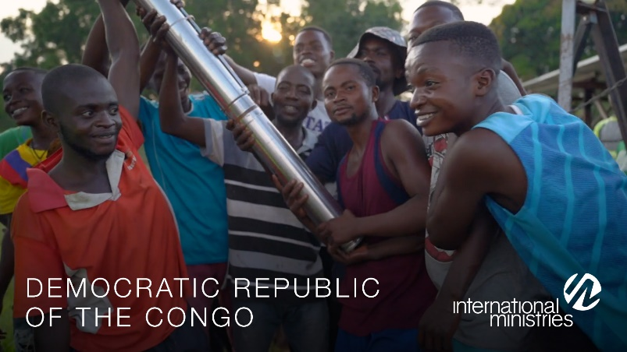
As you watch, I want to encourage you to consider prayerfully how God might be calling you, your family, and our church to participate in these kingdom ministries.

With blessings,
[church pastor or mission chair]

