SENDING YOUR CHURCH WMO EMAILS SAMPLE EMAIL 2

Hello!
As part of our month dedicated to international mission, last week I asked you to watch a brief video about the ministry of four of International Ministries’ global servants in the Democratic Republic of the Congo.
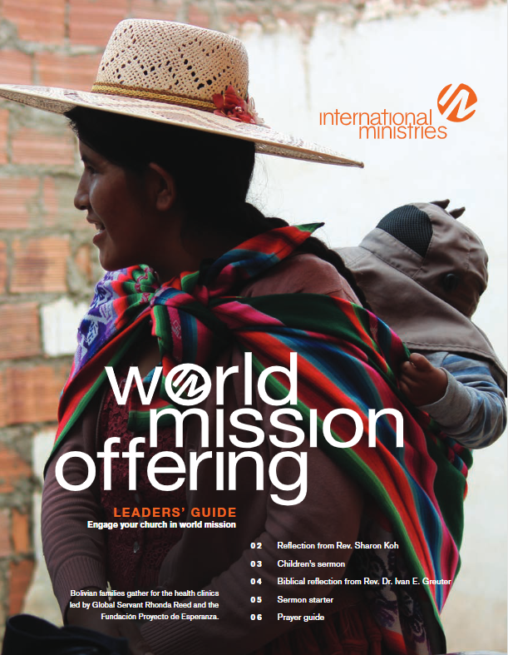
This week, I want to share with you the International Ministries (IM) Leaders’ Guide, which includes a month of short prayers written by IM global servants. You can download a copy here.
As you pray these prayers with IM global servants, you partner with them in discipleship and education, ministry to survivors of human trafficking and global slavery, and initiatives in economic development, peace-making, and justice.
Can your small group commit to pray a few of these prayers together each week as you meet? Can your family commit to praying one of these prayers together each night at dinner?
May God use the people in our church to bless the work of these faithful servants around the globe.

Serving with you in mission,

[church pastor or mission chair]

